EXPT NO:08 | MINI PROJECT  TOURISM DATASET

AIM:
To import, clean, transform, inspect, analyze, and visualize the Tourism Dataset using Python, Pandas, NumPy, and Matplotlib, and to derive meaningful insights from visitor, rating, and revenue data.

Procedure

1. Import the required Python libraries such as Pandas, NumPy, and Matplotlib.
2. Import the Tourism Dataset using pd.read_csv() and store it in a DataFrame.
3. Verify the successful import by checking the dataset shape and displaying the first few records.
4. Check the dataset for missing/null values using isnull().sum().
5. Check for duplicate records using duplicated().sum().
6. Remove duplicate records using drop_duplicates().
7. Check the data types of all columns using dtypes.
8. Perform data transformation by creating a new Revenue_per_Visitor column using Revenue divided by Visitors.
9. Inspect the structure and information of the dataset using info().
10. Perform statistical analysis using describe() to obtain count, mean, standard deviation, minimum, maximum, and percentile values.
11. Filter the dataset based on visitor count to identify tourism records with more than 500,000 visitors.
12. Perform correlation analysis among Visitors, Rating, Revenue, and Revenue_per_Visitor.
13. Create a bar chart to visualize total visitors by tourism category.
14. Create a histogram to visualize the distribution of visitors.
15. Create a scatter plot to analyze the relationship between visitors and revenue.
16. Create box, bar, and line plots to visualize revenue distribution, average revenue by category, and revenue across tourism records.
17. Export the cleaned and transformed dataset into a new CSV file using to_csv()

CODE:

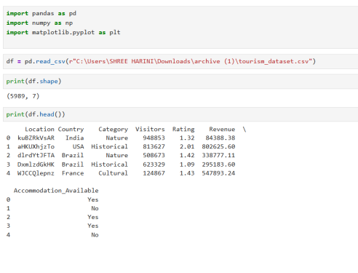

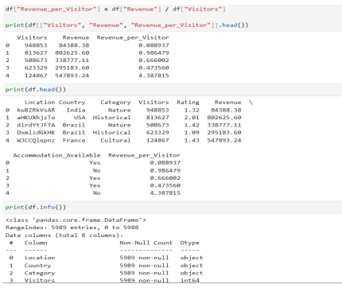

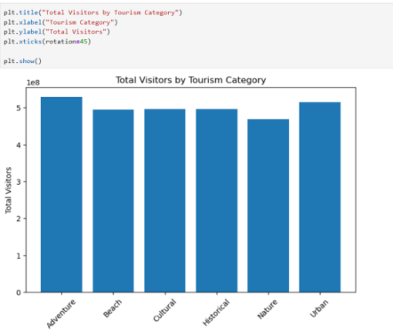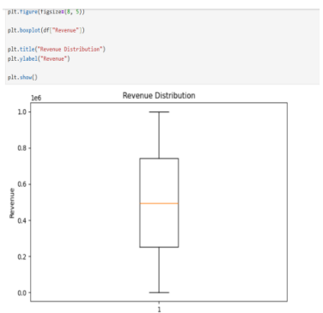

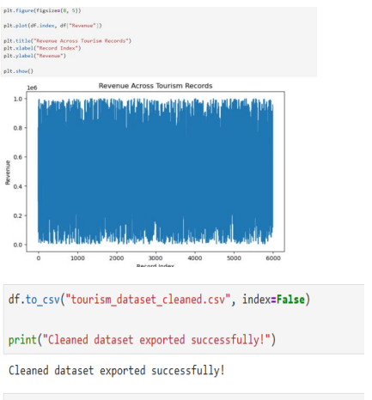

RESULT:
Thus, the Tourism Dataset was successfully imported, cleaned, transformed, inspected, statistically analyzed, correlated, and visualized using Python. Various Matplotlib visualizations were generated to understand visitor and revenue patterns, and the cleaned dataset was successfully exported as a CSV file.

